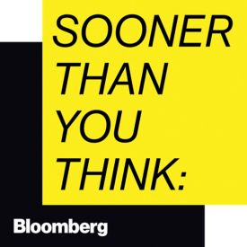
Subject: Request to attend Sooner Than You Think 2019
Dear,
I am requesting approval to attend Sooner Than You Think London, Bloomberg Live’s flagship tech summit, taking place June 11-12 at Central Hall, Westminster, London.
Here is a link to the event website: www.bloomberglive.com/styt-london19/
Bloomberg Live brings together the expertise of the largest newsroom in the world with the immense data and analytical power of Bloomberg Intelligence and Bloomberg Global Data to enable our celebrated moderators and speakers to produce compelling, news-making conversations.
The Sooner Than You Think series has taken place Paris, New York and Singapore and this year it arrives in London as Bloomberg's flagship tech summit. It brings together more than 800 of the planet's smartest minds to answer vital questions around the future of work and digital transformation, global commerce, mobility and what the future holds for London. There are great networking opportunities too, and I’ll come back to the office with a wealth of knowledge.
I believe attending Sooner Than You Think will help the business deliver on the following projects and objectives:
(add projects and objectives here)
These are the approximate costs associated with attending:
- Transportation:
- Hotel (2 nights):
- Meals (breakfast and lunch are included on June 12):
- Registration Fee:
Total:
Only select individuals can attend this event and I would like to apply to attend as soon as possible, so not to miss out.
I am energised at the prospect of attending the event and look forward to hopefully sharing my learnings with the business.
Thank you for considering my request.
Regards
(Your name)

